**Video Production**

**Unit Plan**

Objective: Concept / Topic to teach:

* Students will learn about the process of creating a video for education / Entertainment.
* Students will demonstrate their understanding of digital media by creating a series of videos using different themes for each video.
* Student will be introduced to creators, influencers, and directors of digital media.
* Students will define terms related to video production
* Students will create an original final project using the skills they have learned to create a video that incorporates editing, music, lighting and special effects.

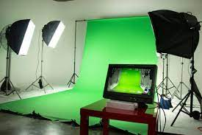

Standards Addresses

Technology Standards (ISTE)

Empowered Learner: (1) Students leverage technology to take an active role in choosing, achieving, and demonstrating competency in their learning goals, informed by the learning sciences. (1a) Students articulate and set personal learning goals, develop strategies leveraging technology to achieve them and reflect on the learning process itself to improve learning outcomes. (1b)Students build networks and customize their learning environments in ways that support the learning process. (1c) Students use technology to seek feedback that informs and improves their practice and to demonstrate their learning in a variety of ways. (1d) Students understand the fundamental concepts of technology operations, demonstrate the ability to choose, use and troubleshoot current technologies and are able to transfer their knowledge to explore emerging technologies.

Digital Citizen: Students recognize the rights, responsibilities and opportunities of living, learning and working in an interconnected digital world, and they act and model in ways that are safe, legal and ethical. (2b) Students engage in positive, safe, legal and ethical behavior when using technology, including social interactions online or when using networked devices.

Knowledge Constructor: Students critically curate a variety of resources using digital tools to construct knowledge, produce creative artifacts and make meaningful learning experiences for themselves and others. (3b) Students evaluate the accuracy, perspective, credibility and relevance of information, media, data or other resources. (3c) Students curate information from digital resources using a variety of tools and methods to create collections of artifacts that demonstrate meaningful connections or conclusions.

Creative Communicator: Students communicate clearly and express themselves creatively for a variety of purposes using the platforms, tools, styles, formats and digital media appropriate to their goals. (6a) Students choose the appropriate platforms and tools for meeting the desired objectives of their creation or communication.(6b) Students create original works or responsibly repurpose or remix digital resources into new creations.(6c) Students communicate complex ideas clearly and effectively by creating or using a variety of digital objects such as visualizations, models or simulations.(6d) Students publish or present content that customizes the message and medium for their intended audiences.

Literacy: Grade 8: (1.1) 1. Oral Expression and Listening. (2.1) 1. Quality comprehension and interpretation of literary texts demand self-monitoring and self-assessment. (3.3) Quality reasoning relies on supporting evidence in media.

Math: Grade 8: (4.1) Transformations of objects can be used to define the concepts of congruence and similarity. (4.2) Direct and indirect measurement can be used to describe and make comparisons.

Visual Art: Grade 6 –8: (1.2) Employing visual images. (1.3) Evaluating meaning and communication of art. (3.1) Identifying and using process.

Specific Objectives:

* Students will create a series of videos that will incorporate their interests and creativity in order to share their connections to the world around them.
* Prior to any video production, students will develop a script or storyboard that will show the story in which they wish to share with an audience.
* Each student is responsible for recording, editing, adding visual effects, music, sound effects and other additions to provide a good quality video.
* Students will create art work, logo, or visuals for opening sequence or titles for their video.
* Any material used from other sources will be appropriately cited and credit given in the conclusion of the video.
* Students will create a final project that is the culmination of the digital media techniques that they have learned over the course of the program.

Required Materials:

* Paper
* Pencil
* Computer with web camera and microphone
* Digital editing program (free) Screencastify <https://www.screencastify.com/>
* Digital editing Program (professional) We Video <https://www.wevideo.com/>
* Optional Tools – DSLR camera and memory card.
* Optional Tools – Lighting equipment with diffusors.
* Green Screen
* Google Account to save video and provide links to share productions.

Introduction/ Discussion: Anticipatory Set:

With the current invention of the social media video sharing service of YouTube the creation of videos has become a cornerstone of many individuals’ daily lives. Producers or ‘Influencers’ have turned the field into an import part of society. Videos can be created to meet the needs of educational, entertainment or simply to share opinions with others. If a ‘YouTuber’ is successful with creating interest in their videos, they can amass a following large enough that each video produces can lead to a financial career. By sharing a collective knowledge base it is possible for viewers to gain skills and share interests that will improve their lives.

Over the years many forms of videos have come and gone and formats have changed. Some of the top formats is the educational format that is typically found on YouTube. Quick entertainment videos like ‘Vines’ or ‘Tik Tok’s’ provide a range of interesting videos. A Review style of video can cover a wide range of interests from foods, music, movies and so on, where the producer of the video shares their views. PSA or public service announcement videos were created in the 1980’s as a way of offering tips that can improve lives and safety. Lastly there is the community service video that covers important aspects of a community’s needs. The time limits for these video can be as short as 30 seconds or up to 10-20 minutes in length. There are those videos that can be longer and a combination of viewer numbers, time viewing and time of video that can dictate the amount of income an influencer can make. Students have grown up with these technologies are clearly consumers but this project is to provide them the opportunity to experience of creating their own content.

Step-By-Step Procedures:

1. Start the lesson by asking the students to define terms related to Video Production

* SCRIPT - The written text of a stage play, screenplay, or broadcast specifically the one used in production or performance.
* STORYBOARD -A panel or series of panels on which a set of sketches is arranged depicting consecutively the important changes of scene and action in a series of shots (as for a film, television show, or commercial)
* RULE OF THIRDS **-** Is a "rule of thumb" or guideline which applies to the process of composing visual images.
* MEDIA- The main means of mass communication (broadcasting, publishing, and the internet) regarded collectively.
* DIGITAL – Anything characterized by electronic and especially computerized technology.
* COPY RIGHT – The exclusive legal right to reproduce, publish, sell, or distribute the matter and form of something (such as a literary, musical, or artistic work)

Example of a good video that engages its audience. <https://youtu.be/tPKsETiwDHY>

[Oral History of 1st world people](https://youtu.be/tPKsETiwDHY)

1. This project is designed to connect the students understanding of modern day art and graphic design to the traditional forms of Cubism and mosaic art from the ancient Greeks. The students will begin the lesson by examining and building their understanding of basic shapes and the differences between geometric shapes and organic shapes. Students will examine video game graphics of the 1980s and compare the art work that is being created by artists today based on basic shapes and colors. Over the course of this project students will begin creating art work based on cubism and modern day 8 bit street art.
2. Students will begin their work on Digital Media with an exploration of videos that are relevant, educational or entertaining, in a school environment. It is appropriate to show examples of videos that one would expect to see students creating. <https://youtu.be/tPKsETiwDHY> Mojo Jr – history of first world stories is a good example. Showing examples of students creating news broadcasts is also a good tool. <https://frontier.aurorak12.org/newscasts> At this point a discussion should be held about what are the most common videos that students watch each day. From this list a series of videos that the students will create should be made, (about 5 videos).
3. Slowly introduce techniques of creating videos as the students’ progress through the assignments. The first video should be a simple video with little to no editing. Added materials like green screen and pans or wipes should be brought in over time, as each video incorporates more and more technology. This will allow for a progression or scaffolding of learning as the projects increase in quality and complexity.
4. Allow students to pick and choose which videos they would like to create over the course of the class. A list of types of videos and run times is important to keep them engaged and focused.

-**You Tube video**. Typically a demonstration or explanation of how to do something. 5-10 minutes in length.

**- Public Service Announcement or PSA**. 30-90 seconds in length.

-**Tik Tok**- entertainment video. 30-90 seconds in length.

**-Community Service Video**. Is a video that can be of a wide range of topics but is typically about something that is important to the student or the community around them.5- 10 minutes in length.

**-Review.** These video can be of movies, books, games, etc. 30 seconds -5 minutes.

1. Once a student has chosen their topic they need to create a script or storyboard of what they would like to create for this week’s project. Scripts typically need the following amounts of dialogue for a story.

30 seconds – 75-80 words.

60 seconds – 160-180 words.

90 seconds – 210-240 words.

5 minutes – 600-800 words.

10 minutes – 1,000-1,300 words.

A script needs to have a description of the scene or where it is taking place. What is going to happen? The dialogue and a closing. The typical format is Act 1, Scene 1, and so on.

Story boards are drawings of what the scene(s) will look like typically using 6 panels and space for dialogue.

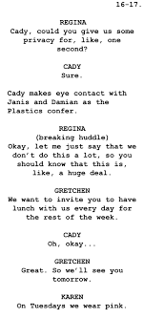 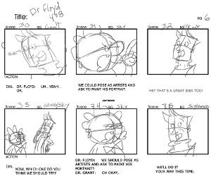

Students will submit their work for approval before recording their videos.

1. Students can begin recording their videos. It is up to the student if they want to use their computers, phones or DSLR to record their videos on. Once the video has been recorded they will edit the video with programs like ScreenCastify, I Movie or We Video etc. As the productions improve more elements need to be added to the projects.
2. Begin with basic videos that are just the video. There should not be any editing other than cutting out pieces or putting pieces together.
3. The next steps are to create logos and other graphics to be used in the video.
4. Panning or wipes can start to be added to the videos
5. Voice over work and added music should be added to the videos.
6. Special effects like using a green screen can be added with other action movements to create a higher quality video.

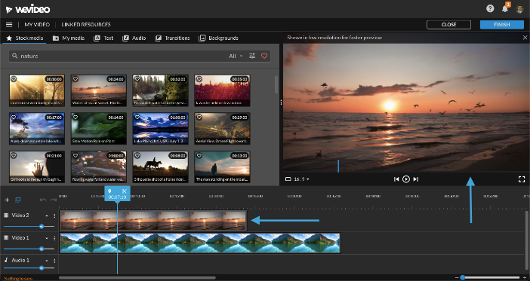 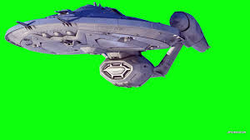

1. Rubric. A one point rubric will be used to evaluate the work. Students will self assess their effort and give themselves credit for the work that was done. They may reflect on any work that was not finished or of low quality. Any work that exceeded expectations should be documented and clearly explained as what was the success. Once this is done for the final grade students will participate in a portfolio review and will discuss with the teacher the good, the missed, and what they would improve on. A final grade will then be given.
2. The Final Project: should be a video of the students design in which they will combine the skills learned in the class. The video should be at least 90 seconds to 5 minutes in time and include many of the designs and skills learned in the class. When complete the video should be shared with the class.

Summary / Closure:

After completing the project students should have mastered a basic understanding Digital Media Productions.

The students will have a completed a series of videos covering a wide range of materials.

Students will have the ability to edit videos, add music, special effects, create scripts, and contribute to the classes knowledge and skills.

A final piece will be created to demonstrate their total knowledge of digital media.

Evaluation: Assessment Based on Objectives:

The final grade will be based on the evaluation of the video piece, participation, effort, and quality of the work.

* Students will earn a percentage for their Portfolio Review, both as presenter and as audience.
* Quality of the work done will be a large part of the grade based on how well they have demonstrated an understanding of the concepts and their depiction. Overall quality of the final video will also have a factor in the grading.
* Effort put into the project will be demonstrated by both the final video and the how well the student worked in class on each project. (Factors include: is the project completed, and does it look like the student worked on it and not other things?)
* The final video as well as the storyboard or script similarities will be combined to make up half of the project’s grade.
* The Rubrics are made up of 5 categories: Project completion (30%), Participation (20%), Originality (20%), Quality of art work (20%), and Follows directions (10 %).

Additional Components that can be included:

Plan for independent practice:

Students who are at a higher level or who have class on a greater number of days will also be given the added task of creating a longer video or adding additional effects to the project. Students can also try using a different style of video to recreate their original work.

Adaptations: (For students with learning disabilities):

Those students with physical disabilities will be asked to either participate in group explorations or help the production of video in whatever capacity they feel most comfortable. Some adaptation tech can sound editing or special effects.

Extensions (For gifted students): Students who complete the assignment early will be given the added assignment of creating a second video using greater detail in their design, storyboard/ script, or attempt to create a more in-depth video that uses a greater range of elements in the recording and editing process.

**Resources for example videos:**

Video Play list for Digital Production Class

*Mojo Jr.*

Side by Side Remake. - <https://youtu.be/KGChuzhGGRU>

First nations Oral History- <https://youtu.be/tPKsETiwDHY>

Interview Talk Show - <https://youtu.be/NuLa3ui8LcI>

Green Screen Dance - <https://youtu.be/F30chtX8yI8>

Dancing - <https://youtu.be/pC2JYSnE0LI>

True or False - <https://youtu.be/GBPbejRwwsI>

Avenger’s game show - <https://youtu.be/RDHFgwh-g30>

Kids Review Movies - <https://youtu.be/RXA5w-ko8dg>

|  |  |  |  |  |  |
| --- | --- | --- | --- | --- | --- |
| **Video Assessment Rubric** | | | | |  |
| ISTE-S #6-Students communicate clearly and express themselves creatively for a variety of purposes using the platforms, tools, styles, formats and digital media appropriate to their goals.  CCSS.ELA-LITERACY.W.8.1.B-Support claim(s) with logical reasoning and relevant evidence, using accurate, credible sources and demonstrating an understanding of the topic or text. | | | **Overall ScoreA-Advanced**  **P-Proficient**  **NP-Not Proficient** |  |
| **Reflection on Needs to meet expectations** | **Expectations** | **Reflection on Strengths that exceed expectations** | **Overall Teacher Feedback** | | |
|  | **INTRODUCTION**-presenter role, and topic |  |  | | |
|  | **WHAT**-presentation content shows understanding of presenter's purpose for the topic and identifies the goal of the presentation |  |
|  | **WHO**-presenter and presentation clearly identified an audience and kept the audience in mind throught the presentation |  |  | | |
|  | **WOW**-presenter uses dynamic and descriptive language to "HOOK" the audience into their presentation |  |
|  | **WHY**-clearly identifies the problem and solution to impact the audience |  |
|  | **WHEN/ASK/WRAP UP**-conclusion  includes a call to action(additional meeting,invitation for response etc.) |  |
|  | **ORGANIZATION**-Presentation is well organized and easily understood by the audience |  |
|  | **PACING**-Presenter voice was clear, even throughout the presentation |  |
|  | **VISUALS/GRAPHICS**-enhance the presentation and audience's understanding of the focus for the presentation |  |
|  | **CREDITING YOUR SOURCES**-links to all resources used in building your knowledge and creating your presentation collected on 1 or 2 credit slide(s) |  |

